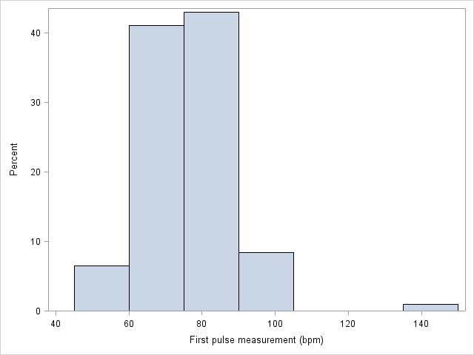

Variables in Creation Order
# | Variable | Type | Len | Format | Informat | Label
1 | HEIGHT | Num | 8 | BEST12. | BEST32. | Height (cm)
2 | WEIGHT | Num | 8 | BEST12. | BEST32. | Weight (kg)
3 | AGE | Num | 8 | BEST12. | BEST32. | Age (years)
4 | GENDER | Num | 8 | BEST12. | BEST32. | Gender
5 | SMOKES | Num | 8 | BEST12. | BEST32. | Regular smoker?
6 | ALCOHOL | Num | 8 | BEST12. | BEST32. | Regular drinker?
7 | EXERCISE | Num | 8 | BEST12. | BEST32. | Frequency of exercise
8 | TRT | Num | 8 | BEST12. | BEST32. | Whether the student ran or sat
9 | PULSE1 | Num | 8 | BEST12. | BEST32. | First pulse measurement (bpm)
10 | PULSE2 | Num | 8 | BEST12. | BEST32. | Second pulse measurement (bpm)
11 | YEAR | Num | 8 | BEST12. | BEST32. | Year of class

