Year of Class
 |  | Frequency | Percent
Valid | 93 | 26 | 24.3
 | 95 | 22 | 20.6
 | 96 | 21 | 19.6
 | 97 | 22 | 20.6
 | 98 | 16 | 15.0
 | Total | 107 | 100.0

Year of Class
 |  | Frequency | Percent
Valid | 93 | 26 | 24.3
 | 95 | 22 | 20.6
 | 96 | 21 | 19.6
 | 97 | 22 | 20.6
 | 98 | 16 | 15.0
 | Total | 107 | 100.0
Year of Class
Frequency Percent
Valid 93 26 24.3
95 22 20.6
96 21 19.6
97 22 20.6
98 16 15.0
Total 107 100.0

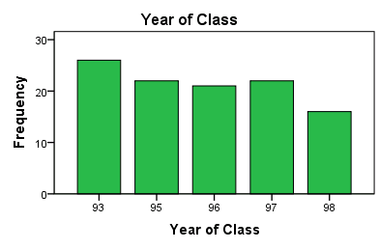

Independent Samples Test
 |  | Levene's Test for Equality of Variances |  | t-test for Equality of Means
 |  | F | Sig. | t | df | Sig. (2-tailed) | Mean Difference | Std. Error Difference | 95% Confidence Interval of the Difference
 |  |  |  |  |  |  |  |  | Lower | Upper
Height (cm) | Equal variances assumed | .049 | .825 | 9.521 | 105 | .000 | 13.828 | 1.452 | 10.948 | 16.708
 | Equal variances not assumed |  |  | 9.500 | 101.086 | .000 | 13.828 | 1.456 | 10.940 | 16.715

